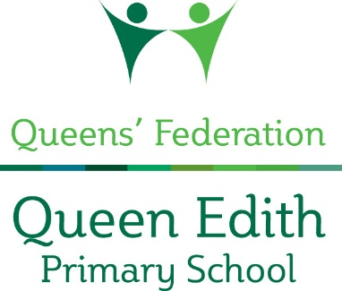

Academic Year 2025-2026

Godwin Way, Cambridge, CB1 8QP
T: 01223 712200
E: oﬀice@queenedith.cambs.sch.uk

www.queensfederation.org.uk

Executive Headteacher:

Mrs Sarah Jarman.

Dear Parent/Carer

Thank you for enquiring about volunteering at Queen Edith Primary School. Any time you can offer to support the children’s learning is greatly appreciated, although we would ask you to commit to coming into school or going on a trip at least twice a year every year that your child is attending the school. This could be to listen to readers, helping with photocopying, putting up displays or accompanying a class on school trips.

We believe that our school should be open and welcoming to all who would like to support the children. We want to ensure that volunteers are welcomed and valued as members of the school community. If you are able to commit to volunteering at Queen Edith and help support the children’s learning we will need to apply for an enhanced DBS Check for you. In order to do this please complete and submit Forms 1-3, the links to which are below:

FORM 1: REGISTRATION FORM FOR VOLUNTARY HELPERS TO BE DBS CHECKED https://forms.office.com/e/6VEEngXTmd

FORM 2 - ORIGINAL DOCUMENTS NEEDED AS PROOF OF ID AND FOR COPYING BY THE SCHOOL OFFICE https://forms.office.com/e/EV8rB5M25e

FORM 3 - DBS CHECKED VOLUNTEER AGREEMENT https://forms.office.com/e/0PriMAvfZT

We can’t start a check for you until all forms have been completed and submitted and your appointed referees have returned their references for you.

At Queen Edith Primary School we have an over-riding duty for the safety of the children in our care. In accordance with ‘Keeping Children Safe in Education’ once you have received your DBS certificate and have brought it in to the school office for copying for our records, we will email you links to the following safeguarding policies and procedures so that you have a copy of each and a link to an online form for you to complete to confirm that you have received the documents:

‘Keeping Children Safe in Education’, September 2025, Part 1,
‘What to do if you’re worried a child is being abused’
'Adult Code of Conduct'

Your help and support are hugely welcome and will make a real difference for the children at our school. We shall look forward to receiving your application and welcoming you into our community.

Yours sincerely
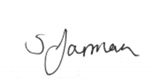
Sarah Jarman
Executive Headteacher

