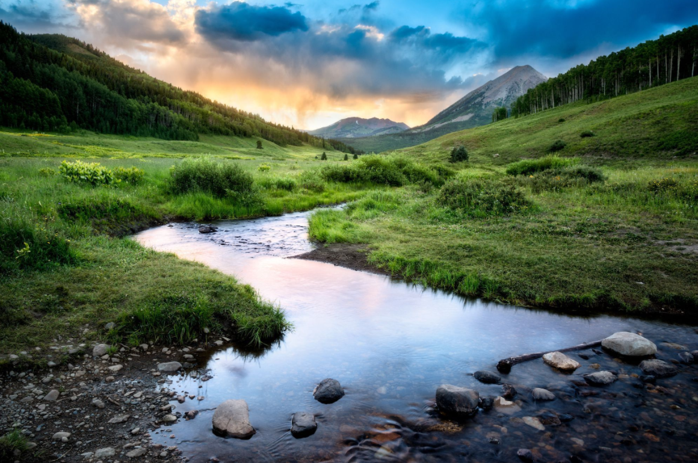
PSHCE:
Healthy lifestyles, including physical, social and mental health.

Mountains and Rivers
During the first part of the summer term, we will focus on the geography of mountains. We will explore how mountains are formed, learn about their key features, and study the impact of weather on mountainous regions. Using atlases, the children will locate the world's major mountain ranges and gain an understanding of glaciers and their role in shaping the landscape.
.

Art and Design:
Painting landscapes: Taking inspiration from David Hockney and using a variety of media and techniques to create texture in landscape art.

RE:
Christianity – Beliefs: How did the world begin?

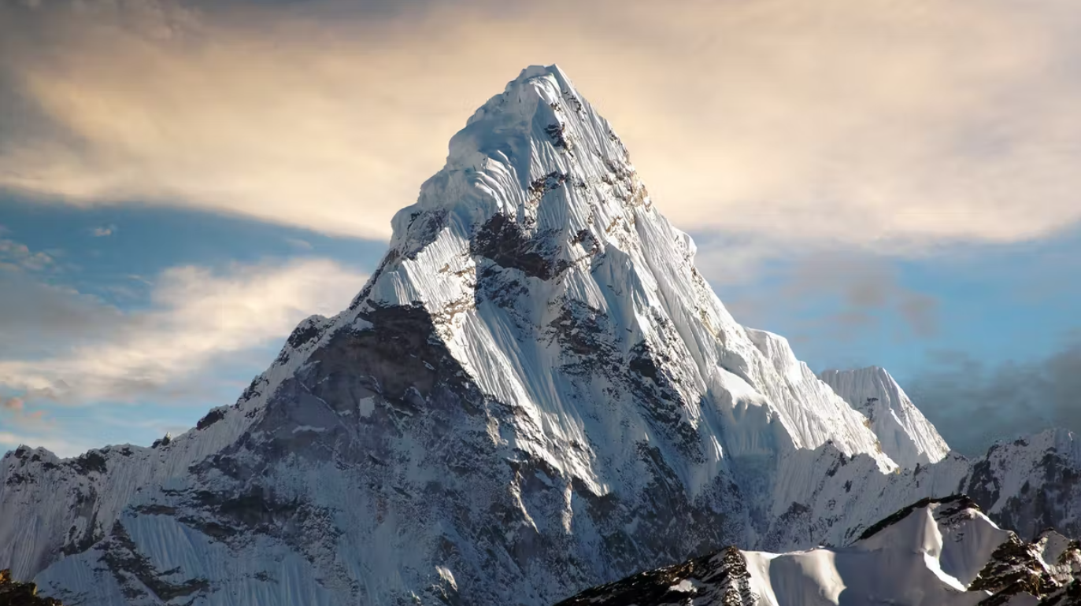

Science:
Children will explore the properties of materials, including thermal insulation and conduction, transparency, hardness and response to magnets.

Computing:
Purple Mash: Coding
Understand simulation, decomposition, abstraction and friction in code.

English:
- Non-fiction:
Non-chronological report-Mount Everest using subheadings and glossary.
- Fiction:
Narrative-Mountain description using figurative language.
Grammar: Daily activities focusing on Year 5-level grammar.
Handwriting: Practice joining letters twice a week.
Class read: Running on the Roof of the World by J Butterworth.
In our whole class guided reading activities, we will integrate geography concepts while focusing on vocabulary and comprehension skills.
Spellings: Learning new spellings – these will be sent home weekly.
Reading: Try to read at home at least 5 times a week. As well as reading try and make time to discuss what you have read with someone in your family.
.

Maths:
Angles: classify, estimate, measure, draw, calculate.
Angles: on a straight line and in shapes.
Position and Direction: coordinates, translation, symmetry and reflection.
Decimals: adding and subtracting across 1.

Music:
Expression and Improvisation

PE:
Tuesday: Cricket
Thursday: Athletics

