Science:
- Exploring the planets in our Solar System; asking questions about surface characteristics, composition, orbit, size and distance from our star.
- Looking in depth at the Earth, Sun and Moon.
- Understanding day, night and seasons in relation to rotation on and tilt of Earth’s axis.

Art:
Drawing:
- Exploring tonal shading techniques.
- Using One-Point Perspective to make two-dimensional objects appear three-dimensional.

RE:
Christianity: Commitment.
- Knowing how Christians show commitment to God.

Literacy:
Space themed:
- Planet fact files
- Story writing: stimulus of Baboon on the Moon
- Narrative: stimulus based on the novel Cosmic by F.C. Boyce
Writing focus:
- Fronted adverbials
- Formal and informal language
- Relative clauses

Reading:
Cosmic by Frank Cottrell Boyce

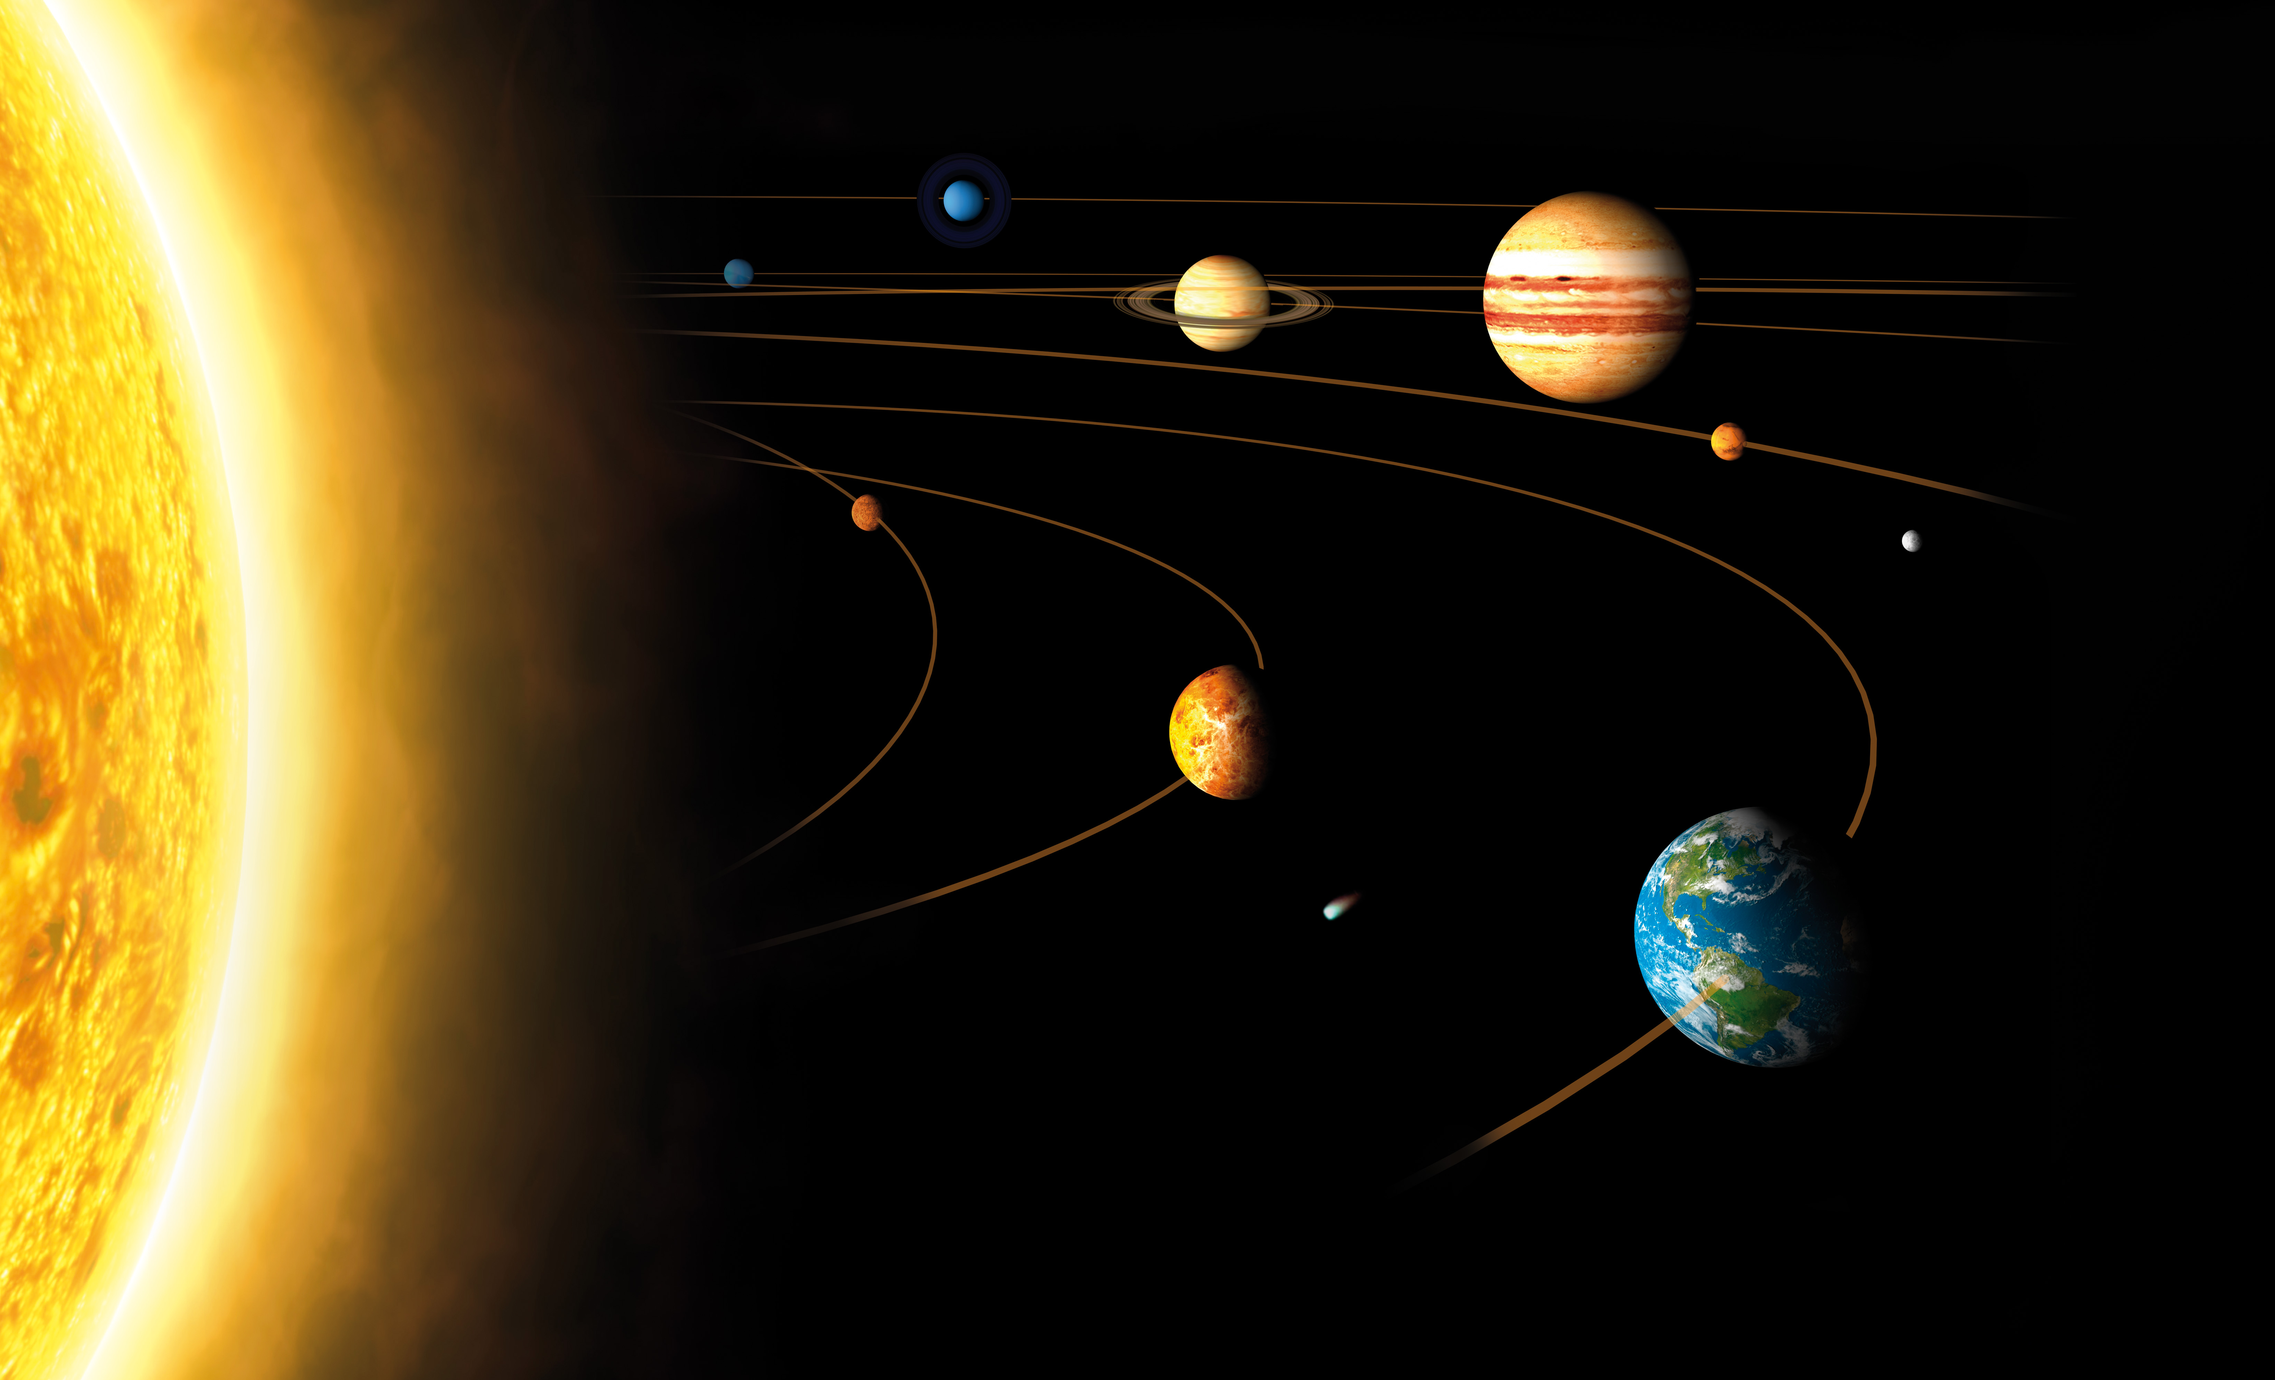
SPACE ACADEMY
This topic will enable children to explore the awe and wonder of our universe. It will inspire them to be curious and to generate their own questions. Through a range of non-fiction texts and research, together we will develop an appreciation of the scale and the physics of our Solar System and beyond. This will enable children to write their own non-fiction texts and explanations, through which they will begin to make sense of the majesty of the universe.

French:
- As-tu un animal ?
Do you have a pet ?

PE:
Invasion Games:
Football and Hockey

PSHCE:
My Emotions

Maths:
- Numbers to a million, counting in powers of ten, comparing and ordering numbers, rounding
- Negative numbers, Roman numerals
- Formal written method of addition and subtraction
- Rounding to estimate sum and difference
- Multi-step addition and subtraction problems
- Interpret and draw charts, line graphs and tables

Computing:
Coding on Purple Mash using 2Code.
Optional Homework Menu
Model making: Research and draw the International Space Station and then make it using recycled materials. | Space mission presentation: Research a space mission and make a presentation to share with the class. | Top Trumps: Create your own planet themed Top Trumps cards. Decide upon what characteristics you would like to write on each card, for example diameter or temperature.
Black holes presentation:  What is a black hole? Make a presentation to share with the class. | Stargazing: Over the course of a few clear nights, look up at the night sky and use a notepad to make notes or draw sketches of what you see. You could ask your parents to help you photograph the night sky using a long exposure so the rotation of the Earth becomes apparent. | Fiction writing: Write a story about living in space or on another planet.
Non-fiction writing: Write a holiday brochure advert for a chosen planet in our Solar System. | Artwork: Draw or paint a picture of a celestial body. | Science-fiction movie character: Draw your own extra-terrestrial creature and write a description of it to pitch it to a Hollywood movie director.

Please note that these tasks are optional. Children will be expected to complete their weekly Maths, English, Spellings homework and daily reading.

