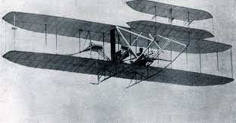
Music:
Composing our own music, thinking about pitch, rhythm and types of instruments.
PSHCE: Managing Change
- Learning that change is a part of life.
- Changing emotions
- Getting ready for Year 3 ☺

Art
Mixing and using paint. Colour! Primary and secondary colours.
Creating artwork inspired by our learning about Sierra Leone.
Up, Up and Away!
This half term, we are learning about flight. We’ll think about the history of flight, explore different kinds of flying machines and invent our own. In science we will continue our habitat investigations.
PE:
Athletics – Continuing to build on running, jumping and throwing skills.
Sports Day
Striking – Hand / eye coordination, using racquets and bats, hitting and striking with control.

History
Learning about the history of flight, particularly the Wright Brothers.
Trip to Duxford Imperial War Museum.

Computing:
Creating digital artwork in different artistic styles, including Pointillism, Mondrian, and Impressionism.

English
Writing: letters, diaries and recount
Grammar: adjectives, adverbs, conjunctions, openers, ? !
Reading: Comprehension, Guided Reading, reading independently.

At home: Read a variety of text types and remember to ask lots of questions about the book, including characters feelings and actions to deepen understanding.
Practise spellings little and often!

Science:
A Habitat investigation.
A minibeast hotel will be made and observations over time will reveal which habitat materials are popular with minibeasts.
Maths:
Investigating 3D shape and pattern. Statistics and how to draw and interpret graphs. Reviewing the four operations and using these to problem solve.
RE:
Cross-religion unit: How do people say thank you?

