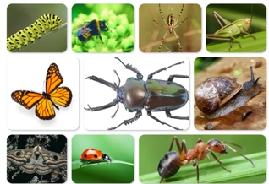
Music:
‘Music That Makes You Dance’
Learn to sing songs within a pitch range, understand tempo changes, mark the beat, and respond to different music styles.

PSHCE:
Financial Capability – Needs and wants and understanding how to manage finances.

Nature Detectives

This half term we will become nature detectives! We’ll be learning about different habitats and microhabitats, as well as finding out about some of the mini beasts that can be found in the UK. We’ll enjoy learning outside the classroom, searching for minibeasts to study and compare, as well as creating our own beautiful butterflies in DT.

If you have any expertise in this topic and would be interested in sharing it with the children, please get in touch!

PE:
Games – Learning different skills to improve throwing, catching and striking.

Athletics

D&T:
Sewing – making a felt butterfly.

Computing:
Purple mash: Questioning and creating graphs.

RE:
Investigating Sikhism. How might a Sikh’s beliefs influence their life?

English:
Writing: Story writing, exploring setting and character description, letter writing and poetry.

Reading: comprehension skills including retrieval, inference and sequencing. Developing fluency and expression as we read aloud.

At home: Read a variety of text types and answer lots of questions about the book. Remember to use clues in the text to explain characters’ feelings and actions.

Maths:
Measurement (length and height), Geometry (position and direction)
Revising all operations; addition, subtraction, division, multiplication.
Recapping fractions of amounts and completing calculations with missing numbers.
Maths problems and reasoning style questions.

Science:
Living things and their habitats
How animals are suited to their habitat.
The difference between things that are alive, dead and have never been alive
Food chains.

