
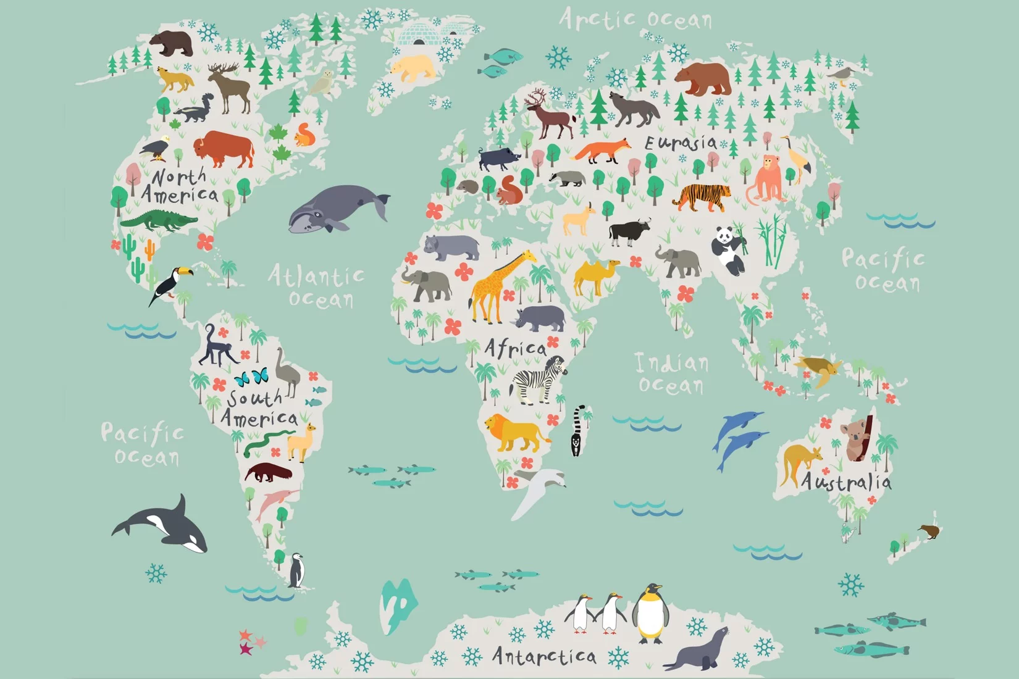

Around the World!
Geography: We will learn about the location of countries, continents in relation to the position of the United Kingdom and our own locality. We will look closely at our local areas and the different features we can see. We will think about the human and physical features of Geography.

Art: We will be looking at different colour types and creating a collage.

English
We will be reading Wombat goes walk about and creating our own versions of the story inspired by this. We will be travelling around the world and writing our own travel journals about this.

Please continue to read with and to your child on a regular basis.
In phonics we will continue to learn different sounds and how they can be written in different ways.
We will continue to set spellings to assist your child’s recall of their phonics learning and to help them learn to spell high frequency words.

Children will be practising their handwriting every day and continue to develop their pre-cursive script.

Science:
Animals, including humans: We will be learning about different animals, where they live, what they eat and their bodies. As well as the different animal groups. We will continue to observe seasonal changes; focusing on Winter and Spring.

Maths:
Number: Addition and subtraction within 20 and Place value within 20.

Practise and develop these oral and mental maths skills (working out in your head):
- Numbers pairs to 10 and 20
- Simple addition and subtraction facts up to 20 at least.
- Place value within 50
- Practise reading and writing numbers up to at least 20.

RE: Islam – Belonging: What difference does being Muslim make to a family?

PSHCE: We will be thinking about Diversity and Community. Children will be thinking about their own cultural beliefs and discussing the beliefs of others in their community too and how we can be respectful of these.

Music: We will be introducing pitch and dynamics.

PE: In dance we will be using travelling actions, movement skills and balancing to inspire us to create and perform movement phrases. We will also be developing our throwing and communication skills with target games.

Computing:
We will be looking at spreadsheets and a topic called Lego builders. This will be using Purple Mash.

