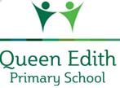
History : We will be exploring castles, their features and types of castles. We will also be exploring the people who lived in castles and the different roles they had.

RE:
We will be thinking about Christianity again and answering the question “Why was Jesus welcomed like a king on Palm Sunday?”
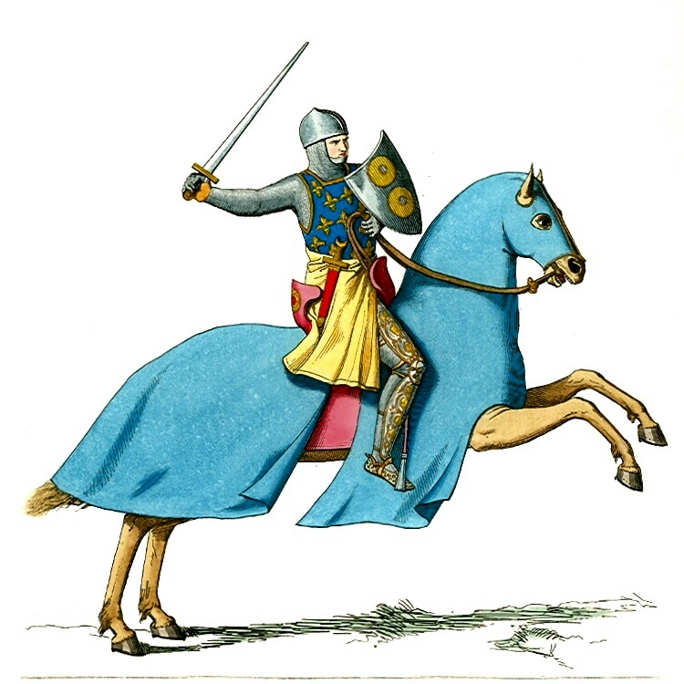
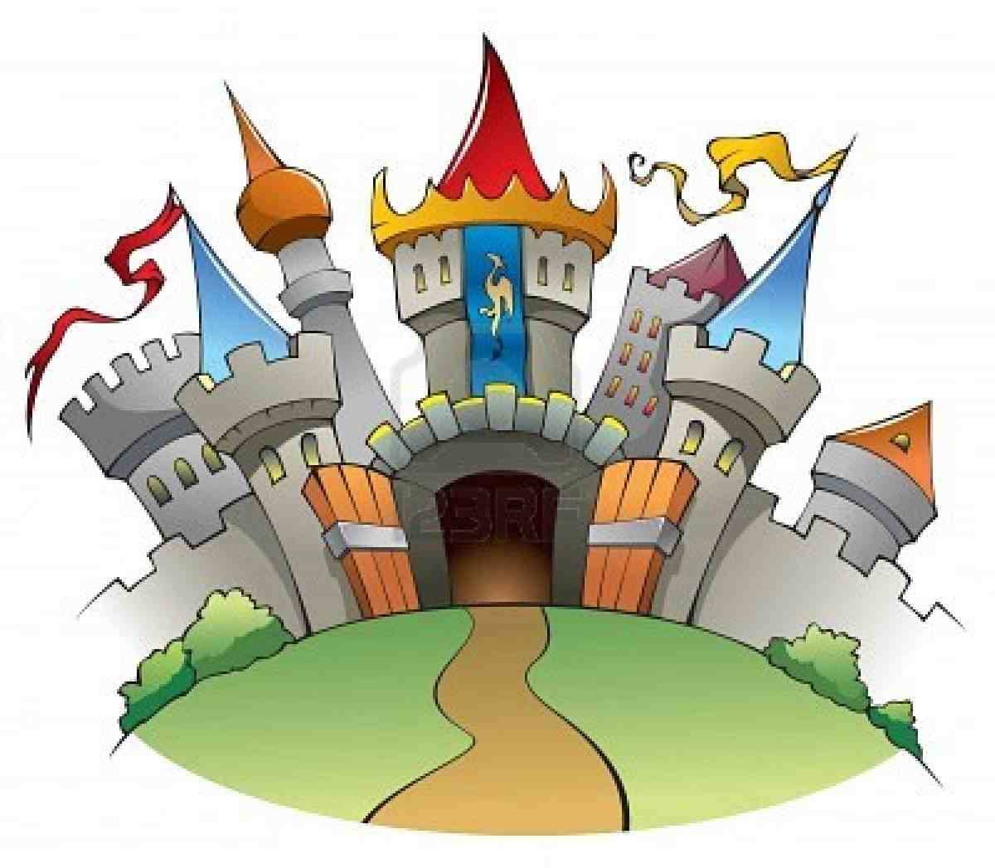
English:
This half-term in English we will be focusing on narrative writing. We will be following a sequence of lessons that will encourage us to think about different writing techniques. The children will be focusing on using adjectives, conjunctions, different sentence starters and more!

Please continue to read daily at home to support your child in our KS1 reading challenge.

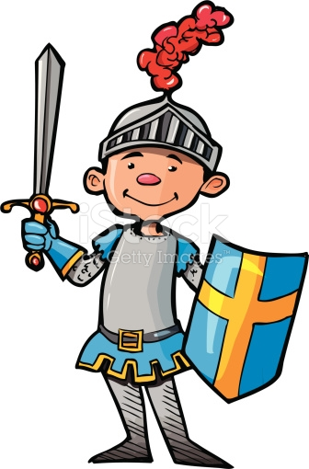
Maths:
We will be focusing on place value within 50. We will look at length and height followed by weight and volume.

Knights and Castles
PSHCE:
We will develop our understanding of how we manage safety and risk.

Design and Technology:
We will investigate, design, create and evaluate castle models with moving parts including sliders and levers.

Music:
We will develop our understanding of pulse and rhythm.

PE:
Gymnastic and Sending and receiving.
We will develop our skills by throwing catching and rolling, as well ask kicking tracking and stopping a ball. Basic skills of jumping, rolling, balancing and travelling are used individually and in combination to create movement sequences.
Science:
Animals:
This half term, we will be continuing to look at animals. We will develop our understanding of the different categories of animals. As well as looking at what omnivores, herbivores and carnivores are.

Computing:
We will using purple mash to develop our understanding of directions and using programs to direct moving things.

