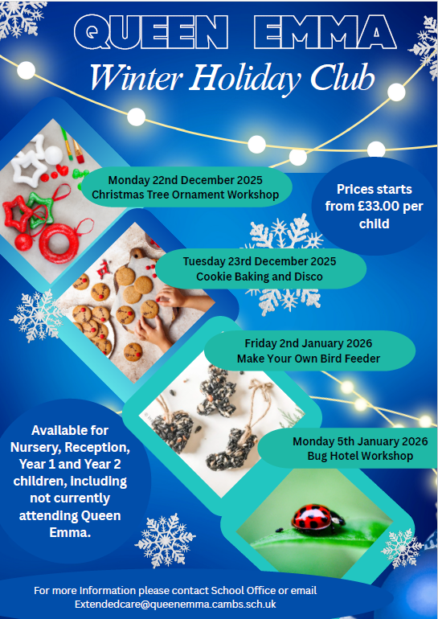


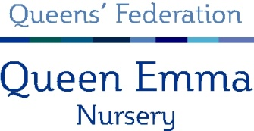

Please tick the boxes to show which sessions you wish to book and hand it in at the School or Nursery Office.

Child’s Name: ..................................................................................................................................

Child’s School: ………………………………………… Class: ……………………………………………………………………….…

 | AM Session  (8:00am - 12:30pm) | PM Session  (1:00 - 5:30pm) | All Day  (8:00am - 5:30pm)
Monday 22nd December
Tuesday 23rd December
Friday 2nd January
Monday 5th January

Please speak to Jovita Dargiene or Mrs Symonds prior to booking if your child has special needs.

On receipt of your booking form we will confirm your sessions and issue an invoice, which must be paid for before Friday 5th December to ensure the early bird booking rates. Invoices can be paid either cash, cheque (Payable to Queens’ Federation), childcare vouchers, Tax Free Childcare or via School Payment gateway if you are a Queen Emma parent.

If your child is staying for either the morning or afternoon session only they will require one healthy snack from home. If they are staying all day they will need to be provided with two snacks from home. Lunchtime will be between 12:30 – 1:00pm, so please bring a packed lunch for your child if staying all day.

PLEASE NOTE WE ARE A NUT FREE SCHOOL.

We will provide the children with drinks during the sessions.

Please be prompt to pick up your child at the end of the sessions. If you are late, you will be charged an additional fee of £5.00 per 5 minutes to cover staff costs.

Fees are payable during periods of absence from the Holiday Club, including sickness.

Email address ..............................................................................................................................
(for booking confirmation)

For more information please contact Jovita Dargiene, Nursery Administrator at extendedcare@queenemma.cambs.sch.uk or 01223 714305 for further information.

